**MOBILE COMPUTING PACKAGE ABSTRACT**

**USSD Messenger**

Using Fonetwish development platform

**Description**

USSD Messenger, an application which can be used for sending messages between GSM mobile phones without the need of internet. User can use this application to send short messages to his friends, and receiver will be able to view the message in his application Inbox. Contacts can also be stored within the application, so that phone numbers need not be re-typed for each message. Unlike SMS, USSD uses a unique session-based bearer ideal for transacting. Information is delivered and responses obtained in real-time.

**Features**

* No need of internet.
* No need of smart phones. The application can be viewed even in a GSM basic mobile phone.
* No application need to be installed in the mobile. The application will be hosted on a server, and a unique USSD code will be used to access the messenger similar to a domain name.

**Screenshot, using an emulator**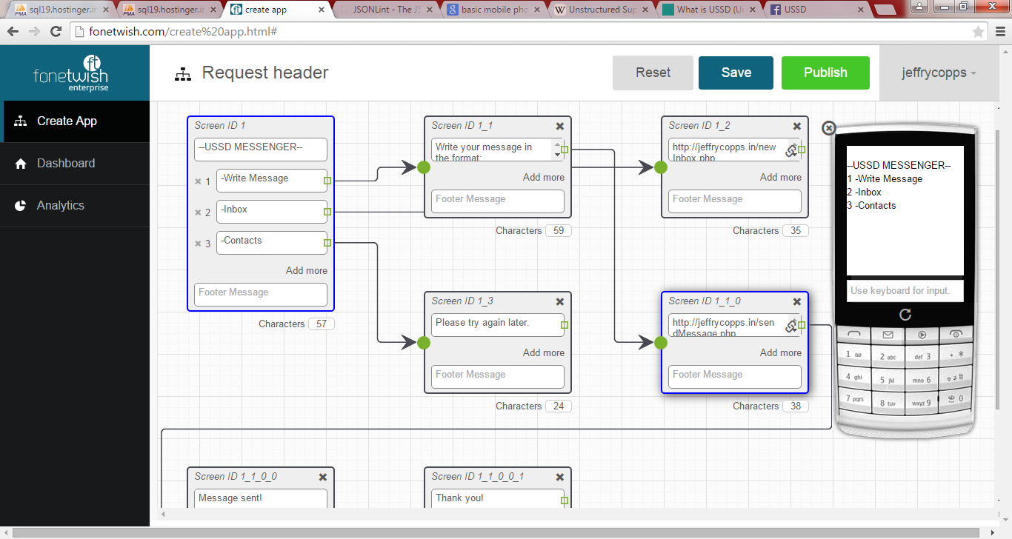

**About USSD**

USSD, unstructured Supplementary Service Data is a unique technology which is only owned by the GSM. This technology is intended for the exchange of information in text form through the channel signals from a GSM network.  
  
USSD differs from the other short message bearer, SMS It is not a store-and-forward bearer like SMS, but a transparent session-based bearer ideal for transacting. Information is delivered and responses obtained in real-time. Simply put, USSD is similar to speaking to someone on a phone as SMS is sending a letter. USSD is also not a point-to-point bearer such as SMS. One subscriber cannot send another text using USSD unless there is a special network application offering such an application.  
  
One can send 182 characters using USSD, but SMS only allows for 140 x 8-bit, or 160 x 7-bit characters. Like SMS, USSD uses the GSM control channels for data transfer. SMS and USSD both use the SDCCH (stand-alone dedicated control channel) when the handset is not in a call. When the handset is busy with a call, USSD will use the FACCH (fast associated control channel) with a significant improvement in transfer speed (1 Kbps).  
  
Response times for interactive USSD based services are generally quicker than those used for SMS. After entering a USSD code on your GSM handset, reply from an GSM operator is displayed within a few seconds. USSD Phase 1 only supports mobile initiated operation (pull operation). USSD Phase 2 specified supports network initiated operation (pull and push operations). Therefore, Phase 2 provides for interactive dialogues  
  
USSD is a session oriented service, and can support a sequence of exchange of information. Phase 2 USSD also allows messages to be pushed onto a Mobile Station. It is several times faster than MO SMS messages since there is no store and forward of messages. The USSD gateway supports an open HTTP interface.  
  
USSD is supported by WAP, SIM Application Toolkit and CAMEL enabling scope for many application.  
  
The USSD gateway will have an interface with the MSC/STP over SS7/SIGTRAN. It uses MAP to receive and send USSD data from the HLR. Generally the USSD functionality is implemented in the following modes:  
  
Pull Mode, will handle Mobile Initiated USSD Requests.  
Push Mode will handle network Initiated USSD Requests.  
  
Mobile Initiated USSD Requests  
  
Mobile Subscriber initiates the dialogue by invoking the Process USSDRequest operation. The network can respond by either invoking a USSDRequest operation or release the dialogue by returning the result to the received Process USSDRequest operation. Both the MS and the network can at any time release the dialogue by sending a RELEASE COMPLETE Radio Layer 3 message (END in TCAP)  
  
Network Initiated USSD Requests  
  
The network initiates the dialogue by invoking the USSDRequest operation. The MS responds by returning the result to the USSDRequest operation. Both the MS and the network can at any time release the dialogue by sending a RELEASE COMPLETE Radio Layer 3 message (END in TCAP).  
  
This use of the SDCCH channel leads to the one drawback with USSD. Because the SDCCH channel is also used by GSM for call-setup, many open USSD sessions may limit new call-setups in congested networks. In practise, this doesn’t happen often and GSM Network Operators can upgrade the radio resources in highly congested cells to prevent this from happening.  
  
Unlike SMS, USSD’s subscriber does not have to create a message, they just call to some combination menu like *123*1234*12*3#. On a GSM network level, the USSD Gateway is defined as a gsmSCF (GSM Service Control Function), whereas an SMSC is defined as another HLR (Home Location Register).  
  
Reference standard specifications:  
  
GSM 02.90 (ETSI TS 100 625, V7.0.0) Specification (USSD) – Stage 1  
[http://www.3gpp.org/ftp/Specs/html-info/0290.htm](http://l.facebook.com/l.php?u=http%3A%2F%2Fwww.3gpp.org%2Fftp%2FSpecs%2Fhtml-info%2F0290.htm&h=hAQFeZ-as&s=1)  
  
GSM 03.90 (ETSI TS 100 549, V7.0.0) Specification (USSD) – Stage 2  
[http://www.3gpp.org/ftp/Specs/html-info/0390.htm](http://l.facebook.com/l.php?u=http%3A%2F%2Fwww.3gpp.org%2Fftp%2FSpecs%2Fhtml-info%2F0390.htm&h=WAQEkcCEd&s=1)  
  
GSM 04.90 (ETSI EN 300 957 V7.0.1 Specification (USSD) – Stage 3

**Conclusion**

The application is very much useful in places where people don’t have internet access. It can be used as a substitute to SMS. Popular social networking websites like, The Facebook, Twitter have enabled USSD based access to their websites now. Though, USSD have its own limitations.

**Done by**

Jeffry Copps(11pw13), Abishek(11pw03), AVR(11pw06) and Karnan(11pw38)**,**

8th semester Msc SWE,

PSG Tech.